Infants Supply List
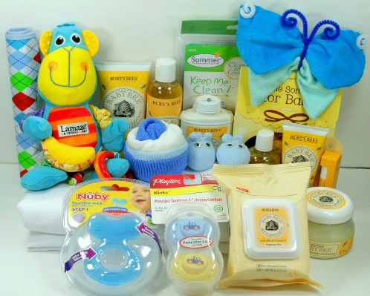
Please read over the supply list that your child will need to be enrolled in our program. We cannot provide services for you if your child does not have their daily required supplies (especially infants). IF YOUR CHILD DOES NOT HAVE THE SUPPLIES NEEDED FOR THAT DAY YOUR CHILD WILL NOT BE ABLE TO STAY AT THE CENTER. You will be REQUIRED to TAKE THE CHILD WITH YOU TO GO PURCHASE THE ITEMS NEEDED THEN YOU CAN RETURN. So please make sure you arrive with ALL THE SUPPLIES your child will need. It would be BEST to send a weekly supply of items instead of daily to prevent you from forgetting. Another suggestion would be to purchase items that are ONLY for school. Example: bottles that stay at school, a pacifier that stays at school, etc. Our staff will provide a weekly list of supplies needed
Note: PARENTS OF ALL AGES PLEASE LABEL ALL OF YOUR CHILD’S ITEMS (this includes sheets, blankets, clothing & etc.)

AGE: INFANTS
SUPPLIES NEEDED FREQUENCY
- Large Bin/Container (that can fit all your child’s supplies in it) Bags are NOT acceptable | - DAILY (Stays at the center)
- Clean Bottles | - DAILY
- Formula & Cereal (if the child is not on our program) | - DAILY
- Pacifier (if use) | - DAILY
- Pampers | - DAILY
- Wipes | - DAILY
- Diaper Ointment (Make sure you complete a CONSENT form for us to Administer it) | - WHEN NEEDED
- At least 3 full sets of change of clothes (weather appropriate) | - DAILY
- Food (when age to eat baby food) When the child turns 1 years old, they can eat our food if you complete an application | - DAILY
- Snacks (when age to eat snacks) | - DAILY
- Clean bibs | - DAILY
- Crib size sheet | - DAILY (TAKE HOME EVERY FRIDAY TO CLEAN IT)
- Feeding spoon | - DAILY
- SIPPY CUP (When child turns 9 months old) | - DAILY
- If your child has ASTHMA, WE NEED INHALER/MEDICATION. PLEASE MAKE SURE YOU COMPLETE A MEDICATION CONSENT FORM, SO THE MEDICATION CAN BE ADMINISTERED | - DAILY (INHALER & MEDICATION MUST STAY AT THE DAYCARE AND NOT BE OUTDATED)

Toddlers Supply List
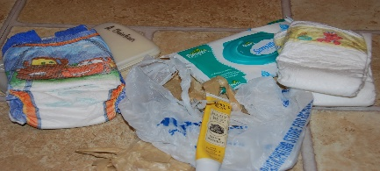
Please read over the supply list that your child will need to be enrolled in our program. We cannot provide services for you if your child does not have their daily required supplies. IF YOUR CHILD DOES NOT HAVE THE SUPPLIES NEEDED FOR THAT DAY YOUR CHILD WILL NOT BE ABLE TO STAY AT THE CENTER. You will be REQUIRED to TAKE THE CHILD WITH YOU TO GO PURCHASE THE ITEMS NEEDED THEN YOU CAN RETURN. So please make sure you arrive with ALL THE SUPPLIES your child will need. It would be BEST to send a weekly supply of items instead of daily to prevent you from forgetting. Another suggestion would be to purchase items that are ONLY for school. Our staff will provide a weekly list of supplies needed.
SUPPLIES NEEDED FREQUENCY
- Large Bin/Container (that can fit all your child’s supplies in it) Bags are NOT acceptable | - DAILY
- Pull-ups | - DAILY
- Wipes | - DAILY
- Box of Tissue | - EVERY TWO MONTHS
- At least 2 sets of Complete change of clothes (weather appropriate) | - DAILY
- Clean Sheet & Blanket | - DAILY (TAKE HOME EVERY FRIDAY TO CLEAN IT)
- Composition Book & 1 pocket Folder | - FOR THE YEAR
- Smock or Old Large Tee Shirt (to paint in) | - FOR THE YEAR
- Large Plastic Bib (so child can feed themselves) | - DAILY
- Facial Mask | - DAILY
- If your child has ASTHMA, WE NEED INHALER/MEDICATION. PLEASE MAKE SURE YOU COMPLETE A MEDICATION CONSENT FORM, SO THE MEDICATION CAN BE ADMINISTERED | - DAILY (INHALER & MEDICATION MUST STAY AT THE DAYCARE AND NOT BE OUTDATED)
POTTY TRAINING, We are more than happy to encourage potty training as long as the child is ready. Parents must partner with teachers for the child to be successful. We cannot potty train children in diapers. Parents will be required to supply pull-ups and wipes.
PLEASE NOTE: We will only assist your child in potty training if you are working on it at home as well.
We will follow through and encourage your child while in care. Potty training will be done in a relaxed manner with the cooperation of the family. We require that the child be at least 2 years of age and must also show signs that they are ready. Positive reinforcements and consistency must be continued at home.
PROPER CLOTHING During potty training your child needs to be dressed in “User friendly” clothing as much as possible. The best items are dresses and pants with elastic waist.
*Please DO NOT dress your child in the following
No tight clothing No shirts that snap in the crotch No pants with snaps/zippers
No overalls or bib type clothing No belts No one piece outfits
The clothes listed above can make it difficult for your child to reach the potty in time. Your child also needs to be able to pull his/her pants up and down and these items will hinder your child’s ability to do so.
REQUIRED SUPPLIES: Two (2) changes of clothing including socks (an extra pair of shoes if available) A bag of pull-ups – you will be notified when the supply is running low.
Preschoolers Supply List

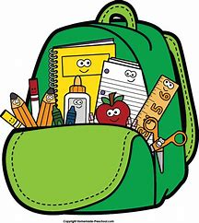

SUPPLIES NEEDED FREQUENCY
- Large Bin/Container (that can fit all your child’s supplies in it) Bags are NOT acceptable | - DAILY
- Wipes | - EVERY TWO MONTHS
- Box of Tissue | - EVERY TWO MONTHS
- At least 2 sets of Complete change of clothes (weather appropriate) | - DAILY
- Clean Sheet & Blanket | - DAILY (TAKE HOME EVERY FRIDAY TO CLEAN IT)
- 2 -Pocket Folders | - FOR THE YEAR
- Glue or glue sticks | - FOR THE YEAR
- A pack of pencils | - FOR THE YEAR
- A pack of crayons | - FOR THE YEAR
- Age-appropriate scissors | - FOR THE YEAR
- Smock or Old Large Tee Shirt (to paint in) | - FOR THE YEAR
- Facial Mask | - DAILY
- If your child has ASTHMA, WE NEED INHALER/MEDICATION. PLEASE MAKE SURE YOU COMPLETE A MEDICATION CONSENT FORM, SO THE MEDICATION CAN BE ADMINISTERED | - DAILY (INHALER & MEDICATION MUST STAY AT THE DAYCARE AND NOT BE OUTDATED)

